**HTP (Humidity Temperature and Pollution) Sensing Robotic Car**

**CODE**

#include<DHT.h>

DHT dht(13,DHT11); //dht11

int incomingByte=0;

const int motora=2;

const int motorb=3;

const int motorc=4;

const int motord=5;

int count=0;

void setup() {

dht.begin();

Serial.begin(9600);

pinMode(11,OUTPUT); //led

digitalWrite(11,LOW);

pinMode(10,OUTPUT); //buzzer

digitalWrite(10,LOW);

pinMode(motora, OUTPUT);

pinMode(motorb, OUTPUT);

pinMode(motorc, OUTPUT);

pinMode(motord, OUTPUT);

digitalWrite (motora,LOW);

digitalWrite (motorb,LOW);

digitalWrite (motorc,LOW);

digitalWrite (motord,LOW); }

void loop()

{ if (Serial.available() > 0)

{ incomingByte = Serial.read();

if(incomingByte=='R') ///// right

{ digitalWrite (motora,HIGH);

digitalWrite (motorb,LOW);

digitalWrite (motorc,LOW);

digitalWrite (motord,LOW); }

if(incomingByte=='L') ///// left

{ digitalWrite (motora,LOW);

digitalWrite (motorb,LOW);

digitalWrite (motorc,HIGH);

digitalWrite (motord,LOW); }

if(incomingByte=='F') ///// front

{ digitalWrite (motora,HIGH);

digitalWrite (motorb,LOW);

digitalWrite (motorc,HIGH);

digitalWrite (motord,LOW); }

if(incomingByte=='B') ///// back

{ digitalWrite (motora,LOW);

digitalWrite (motorb,HIGH);

digitalWrite (motorc,LOW);

digitalWrite (motord,HIGH); }

if(incomingByte=='S') ///// stop

{ digitalWrite (motora,LOW);

digitalWrite (motorb,LOW);

digitalWrite (motorc,LOW);

digitalWrite (motord,LOW);

Serial.println("\n");

float h=dht.readHumidity(); //humidity

Serial.println("humidity:");

Serial.println(h);

delay(500);

float t=dht.readTemperature(); //temperature

Serial.println("temperature:");

Serial.println(t);

if(t>=25.00)

{ for(int i=0;i<10;i++)

{ digitalWrite(10,HIGH); //buzzer

delay(500);

digitalWrite(10,LOW); } }

else

{ digitalWrite(10, LOW); }

delay(500);

//air pollution

int p=analogRead(A0); //mq-6

Serial.println("pollution:");

Serial.println(p);

if(p>=125)

{ for(int i=0;i<10;i++)

{ digitalWrite(11,HIGH); //led

delay(500);

digitalWrite(11,LOW); } }

else { digitalWrite(11, LOW); } } } }

**MODEL PICTURE**

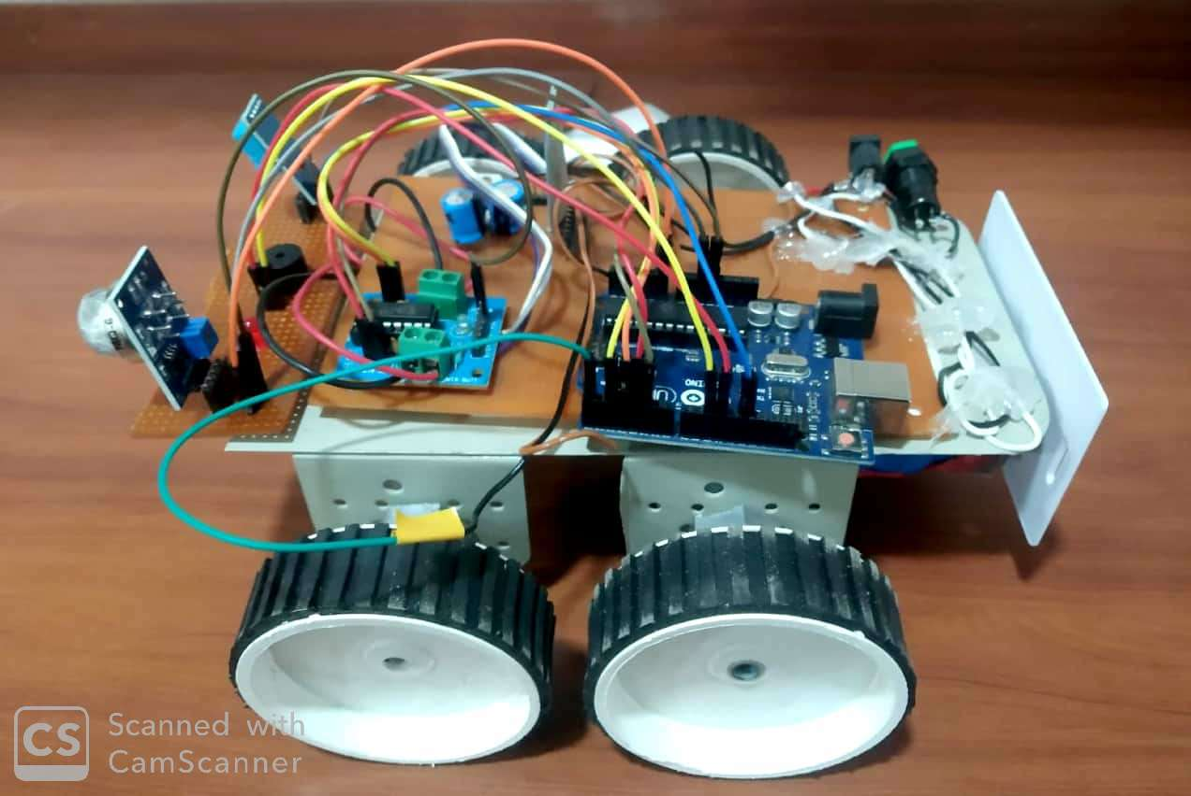

**CIRCUIT DIAGRAM**



